 COMSATS University Islamabad, Lahore

Spring 2020
□ Sessional-1 □ Sessional-II □ Terminal Examination
Course Title: | Semantic Web (Theory) |  |  |  | Course Code: |  | CSE344 | Credit Hours: | 3(2,1)
Course Instructor/s: | Sana Rizwan |  |  |  | Program Name: |  | BSSE
Semester: | 7th | Batch: | FA17 | Section: | C |  | Date:
Time Allowed: | 50 minutes |  |  |  | Maximum Marks: |  |  | 35
Student’s Name: |  |  |  |  | Reg. No.
Important Instructions / Guidelines:
- Rewriting and cuttings are not allowed. All questions are compulsory.

Question 1: (Marks = 05)
Match the Following.
(RDF, RDFS, XML, OWL, RIF, OWL FULL, XMLS, SPARQL)
- Standard for exchanging rules among rule systems, exchange rather than defining a single one-fits-all rule language.
- Facilitate data merging even if the fundamental schemas vary, evolution of schemas over time without requiring all the data clients to be changed.
- Designed to signify rich and complex knowledge about things, groups of things, and relations between things. It is a computational logic-based language such that knowledge expressed can be exploited by computer programs.
- Essential syntax for content structure within documents, no semantics associates with the meaning of the content contained within.
- Capabilities for querying required and optional graph patterns along with their conjunctions and disjunctions.

Question 2: (Marks = 06)

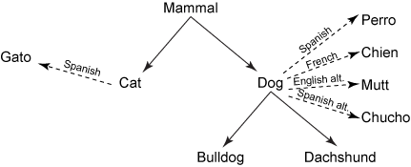
Identify the direct association validity using SKOS among classes. Remember that skos:broaderThan is the direct associativity with strong lines.
According to diagram, write your answer Valid / Invalid:
- ex:Cat skos:broaderThan ex:Mammal ________________________________
- ex:Cat skos:broaderThan ex:Dachshund ______________________________
- ex:Dog skos:broaderThan ex:Gato___________________________________
- ex:Mammal skos:broaderThan ex:Bulldog ____________________________
- ex:Mammal skos:broaderThan ex:Dog _______________________________
- ex:Dog skos:broaderThan ex:Chien__________________________________

Question 3: (Marks = 13)

Complete Semantic Web Architecture Layered Diagram by filling data.

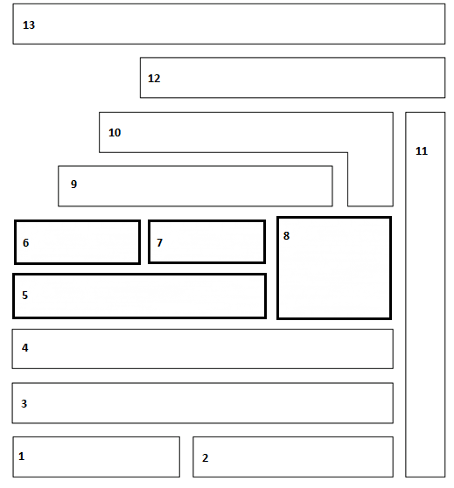
- RDF
- URI
- XML
- OWL DL
- RDFS
- NS
- OWLS
- Unicode
- OWL
- Trust
- SPARQL
- Proof
- SQL
- RIF
- Cryptography
- GUI
- URN
- Logic

Question 4: (Marks = 11)

Select the correct option.

- Which statement is true?
- All XML documents must have a DTD.
- All XML elements must be lower case.
- All XML elements must be properly closed.
- All of the above.
- What is a correct way of referring to a stylesheet called "mystyle.xsl" ?
- <link type="text/xsl" href="mystyle.xsl" />
- <?xml-stylesheet type="text/xsl" href="mystyle.xsl"?>
- <stylesheet type="text/xsl" href="mystyle.xsl" />
- All of the above
- XML Schema is designed to
- be self-descriptive
- display only useful data
- carrying request
- giving response
- RDF uses ______ to identify resources.
- IP Addresses
- Web identifiers
- MAC Address
- Network Address
- Which of these are not the main elements of RDF ?
- root element
- <RDF>
- </RDF>
- <Description>
- RDF Schema does not provide actual application-specific
- objects and properties
- classes and properties
- functions and properties
- files and properties
- RDF is written in
- XSL
- XSLT
- XHTML
- XML
- The XML provides the ________ in which you can write the specialized languages to express the complex interactions between the clients and the services or between the components of a composite service.
- Language
- Metalanguage
- Meta
- Services
- Web Services define a platform-independent standard based on XML to communicate within distributed systems.
- True
- False
- Not always true
- None of these
- Using a ______ you can do exchange the data between the different applications and different platforms.
- Web application
- Web pages
- Web services
- None of these
- Schema is an _____ based alternative
- XHTML
- XSLT
- XSL
- XML

SOLUTION PAPER:

Match the Following. (Marks = 05)
(RDF, RDFS, XML, OWL, RIF, OWL FULL, XMLS, SPARQL)
- Standard for exchanging rules among rule systems, exchange rather than defining a single one-fits-all rule language. (RIF)
- Facilitate data merging even if the fundamental schemas vary, evolution of schemas over time without requiring all the data clients to be changed. (RDF)
- Designed to signify rich and complex knowledge about things, groups of things, and relations between things. It is a computational logic-based language such that knowledge expressed can be exploited by computer programs. (OWL)
- Essential syntax for content structure within documents, no semantics associates with the meaning of the content contained within. (XML)
- Capabilities for querying required and optional graph patterns along with their conjunctions and disjunctions. (SPARQL)

Question 2: (Marks = 06)


Identify the direct association validity using SKOS among classes. Remember that skos:broaderThan is the direct associativity with strong lines.
According to diagram:
- ex:Cat skos:broaderThan ex:Mammal _______________________________ V
- ex:Cat skos:broaderThan ex:Dachshund ____________________________InV
- ex:Dog skos:broaderThan ex:Gato_________________________________InV
- ex:Mammal skos:broaderThan ex:Bulldog __________________________InV
- ex:Mammal skos:broaderThan ex:Dog ______________________________V
- ex:Dog skos:broaderThan ex:Chien________________________________InV

Question 3: Complete Semantic Web Architecture Layered Diagram by filling data. (Marks = 13)

- RDF
- URI
- XML
- OWL DL
- RDFS
- NS
- OWLS
- Unicode
- OWL
- Trust
- SPARQL
- Proof
- SQL
- RIF
- Cryptography
- GUI
- URN
- Logic

Solution:
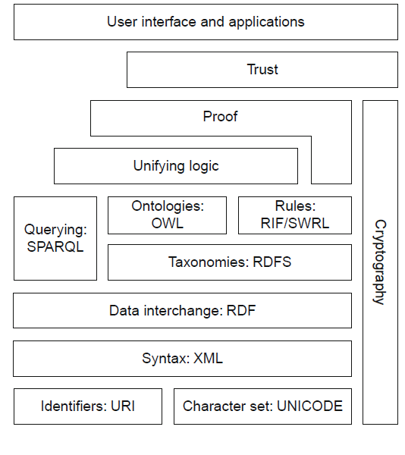

Question 4: (Marks = 11)
Select the correct option.
- C
- A
- A
- B
- C
- B
- D
- B
- A
- C
- D

